CMSC 312 Assignment 2

Jordan Dube

OUTPUT FILE

Question1, Part 1 (Correct counting semaphore implementation)

Corresponds to prod-con-1.c

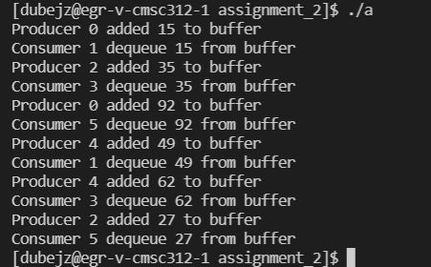

Question 1, Part 2 (Incorrect counting semaphore implementation)

Question 2 (FIFO queue implementation with counting semaphores)

Corresponds to prod-con-3.c

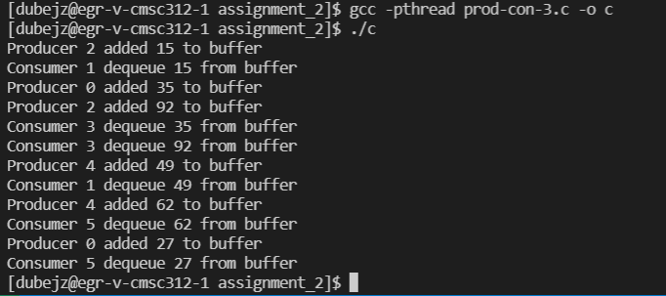

Question 3 (n-bound reader-writer problem)

Corresponds to reader-writer-1.c

